Lab-7

# Write a Python program that computes the value of the Gaussian distribution at a given vector X. Hence, plot the effect of varying mean and variance to the normal distribution.

**Source Code:**

import numpy as np

import matplotlib.pyplot as plt

def gaussian_distribution(X, mu, sigma):

return (1 / (np.sqrt(2 * np.pi * sigma**2))) * np.exp(-((X - mu)**2) / (2 * sigma**2)) X = np.linspace(-10, 10, 1000) # Example means and variances to plot means = [0, -2, 2]

variances = [0.5, 1, 2]

plt.figure(figsize=(12, 6)) plt.subplot(1, 2, 1) for mu in means:

Y = gaussian_distribution(X, mu, 1) # Keeping variance constant at 1 plt.plot(X, Y, label=f'Mean: {mu}') plt.title('Effect of Varying Mean') plt.xlabel('X') plt.ylabel('Probability Density') plt.legend() plt.subplot(1, 2, 2)

for sigma in variances:

Y = gaussian_distribution(X, 0, sigma) # Keeping mean constant at 0 plt.plot(X, Y, label=f'Variance: {sigma}') plt.title('Effect of Varying Variance') plt.xlabel('X')

plt.ylabel('Probability Density') plt.legend()

plt.tight_layout() plt.show()

# Output:

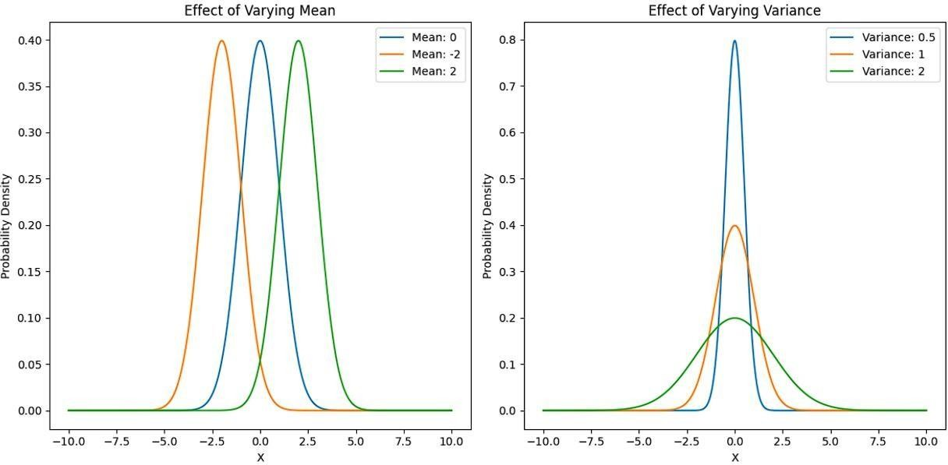

1. **Write a python program to implement linear regression. Source Code:**

import numpy as np

import matplotlib.pyplot as plt np.random.seed(0) x = 2 * np.random.rand(100, 1)

y = 4 + 3 * x + np.random.randn(100, 1) def linear_regression(x, y):

x_mean = np.mean(x) y_mean = np.mean(y)

num = np.sum((x - x_mean) * (y - y_mean)) # Numerator denom = np.sum((x - x_mean) ** 2)# Denominator beta_1 = num / denom

beta_0 = y_mean - beta_1 * x_mean return beta_0, beta_1 def predict(x, beta_0, beta_1):

return beta_0 + beta_1 * x

beta_0, beta_1 = linear_regression(x, y) y_pred = predict(x, beta_0, beta_1) plt.scatter(x, y, color='blue', label='Data points')

plt.plot(x, y_pred, color='red', label=f'Regression Line (y={beta_0:.2f} + {beta_1:.2f}x)') plt.xlabel('x') plt.ylabel('y')

plt.title('Linear Regression using OLS') plt.legend() plt.show()

print(f"Intercept (beta_0): {beta_0:.2f}") print(f"Slope (beta_1): {beta_1:.2f}")

# Output:

1. **Write a python program to implement gradient descent. Source Code:**

import numpy as np

import matplotlib.pyplot as plt np.random.seed(42) x = 2 * np.random.rand(100, 1)

y = 4 + 3 * x + np.random.randn(100, 1)

def gradient_descent(x, y, learning_rate=0.01, n_iterations=1000): m = len(y) theta_0 = 0 # Initial intercept theta_1 = 0 # Initial slope

cost_history = [] # Keep track of the cost function for each iteration for iteration in range(n_iterations): y_pred = theta_0 + theta_1 * x

d_theta_0 = (1 / m) * np.sum(y_pred - y) d_theta_1 = (1 / m) * np.sum((y_pred - y) * x) theta_0 = theta_0 - learning_rate * d_theta_0 theta_1 = theta_1 - learning_rate * d_theta_1 cost = (1 / (2 * m)) * np.sum((y_pred - y) ** 2) cost_history.append(cost)

if iteration % 100 == 0:

print(f"Iteration {iteration}: Cost = {cost:.4f}") return theta_0, theta_1, cost_history learning_rate = 0.01

n_iterations = 1000

theta_0, theta_1, cost_history = gradient_descent(x, y, learning_rate, n_iterations) y_pred = theta_0 + theta_1 * x plt.figure(figsize=(10, 4))

plt.subplot(1, 2, 1) plt.plot(range(n_iterations), cost_history, 'b-') plt.title('Cost Function over Iterations') plt.xlabel('Iterations')

plt.ylabel('Cost') plt.subplot(1, 2, 2) plt.scatter(x, y, color='blue', label='Data points')

plt.plot(x, y_pred, color='red', label=f'Regression Line (y={theta_0:.2f} + {theta_1:.2f}x)') plt.xlabel('x') plt.ylabel('y')

plt.title('Linear Regression using Gradient Descent') plt.legend() plt.tight_layout() plt.show()

print(f"Intercept (theta_0): {theta_0:.2f}") print(f"Slope (theta_1): {theta_1:.2f}") **Output:**

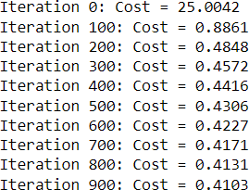

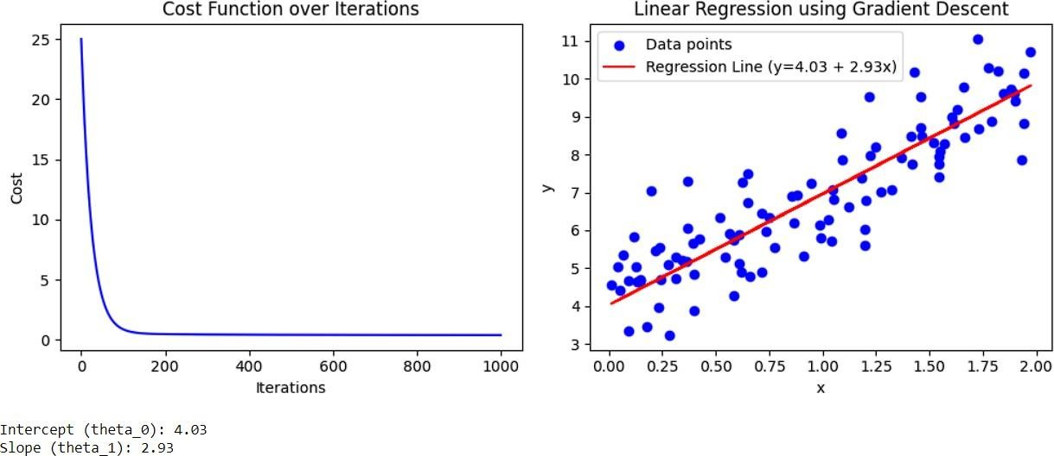

# Write a python program to classify different flower images using MLP. Source Code:

import tensorflow as tf

from tensorflow.keras import layers, models import numpy as np import matplotlib.pyplot as plt from PIL import Image

import io

import ipywidgets as widgets

from IPython.display import display batch_size = 32

img_height = 180

img_width = 180

data_dir = r"C:\Users\anupa\OneDrive\Desktop\Assignment_Sem-3\Python\flowers" # Replace with your dataset path train_ds = tf.keras.preprocessing.image_dataset_from_directory(

data_dir, validation_split=0.2, subset="training", seed=123, image_size=(img_height, img_width), batch_size=batch_size) class_names = train_ds.class_names

normalization_layer = layers.experimental.preprocessing.Rescaling(1./255) train_ds = train_ds.map(lambda x, y: (normalization_layer(x), y))

model = models.Sequential([ layers.Flatten(input_shape=(img_height, img_width, 3)), layers.Dense(128, activation='relu'), layers.Dense(64, activation='relu'),

layers.Dense(5, activation='softmax') # 5 flower classes

])

model.compile(optimizer='adam', loss='sparse_categorical_crossentropy', metrics=['accuracy']) def preprocess_image(image):

image = image.resize((img_height, img_width)) # Resize the image image_array = np.array(image) / 255.0 # Normalize the image

image_array = np.expand_dims(image_array, axis=0) # Add batch dimension return image_array def predict_flower(image):

processed_image = preprocess_image(image) prediction = model.predict(processed_image) predicted_class =

np.argmax(prediction) return class_names[predicted_class] def on_upload_change(change):

uploaded_file = change['new'] if uploaded_file:

img = Image.open(io.BytesIO(uploaded_file[0]['content'])) display(img) flower_class = predict_flower(img) print(f"Predicted flower class: {flower_class}")

uploader = widgets.FileUpload(accept='image/*', multiple=False) uploader.observe(on_upload_change, names='value') display(uploader)

# Output:

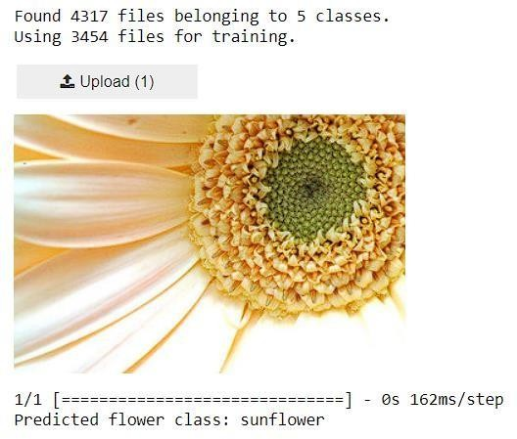

1. **Write a python program to classify different flower images using the SVM classifier. Source Code:**

import numpy as np import tensorflow as tf

from tensorflow.keras.applications import VGG16 from tensorflow.keras.preprocessing import image from tensorflow.keras.applications.vgg16 import preprocess_input from sklearn.svm import SVC from sklearn.model_selection import train_test_split from PIL import Image

import io

import ipywidgets as widgets

from IPython.display import display, clear_output import os

def load_and_preprocess_data(data_dir, img_height, img_width):

images = [] labels = []

class_names = sorted(os.listdir(data_dir))

for class_index, class_name in enumerate(class_names):

class_dir = os.path.join(data_dir, class_name) for img_name in os.listdir(class_dir):

img_path = os.path.join(class_dir, img_name)

img = image.load_img(img_path, target_size=(img_height, img_width)) img_array = image.img_to_array(img) img_array = preprocess_input(img_array) images.append(img_array) labels.append(class_index)

return np.array(images), np.array(labels), class_names def extract_features(model, images): features = model.predict(images) return features

data_dir = r"C:\Users\anupa\OneDrive\Desktop\Assignment_Sem-3\Python\flowers" # Replace with your dataset path img_height = 180

img_width = 180

images, labels, class_names = load_and_preprocess_data(data_dir, img_height, img_width)

base_model = VGG16(weights='imagenet', include_top=False, input_shape=(img_height, img_width, 3)) base_model.trainable = False

features = extract_features(base_model, images)

features_flat = features.reshape(features.shape[0], -1) # Flatten the features

X_train, X_test, y_train, y_test = train_test_split(features_flat, labels, test_size=0.2, random_state=42) svm =

SVC(kernel='linear') # Using a linear kernel for SVM svm.fit(X_train, y_train)

def preprocess_image(img):

img = img.resize((img_height, img_width)) # Resize the image img_array = np.array(img)

img_array = preprocess_input(img_array) # Normalize the image img_array = np.expand_dims(img_array, axis=0) # Add batch dimension return img_array

def predict_flower(img):

processed_image = preprocess_image(img)

features = extract_features(base_model, processed_image)

features_flat = features.reshape(features.shape[0], -1) # Flatten the features prediction = svm.predict(features_flat) return class_names[prediction[0]] def on_upload_change(change):

uploaded_file = change['new'] if uploaded_file:

img = Image.open(io.BytesIO(uploaded_file[0]['content'])) clear_output(wait=True) display(img)

flower_class = predict_flower(img) print(f"Predicted flower class: {flower_class}")

uploader = widgets.FileUpload(accept='image/*', multiple=False) uploader.observe(on_upload_change, names='value') display(uploader)

# Output:

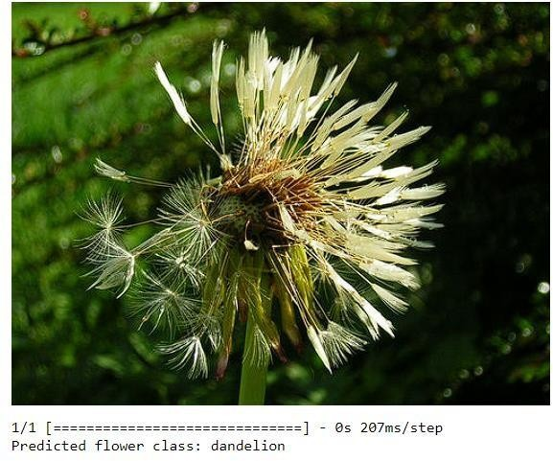

1. **Write a python program to classify different flower images using CNN. Source Code:**

import tensorflow as tf

from tensorflow.keras import layers, models

from tensorflow.keras.preprocessing import image from PIL import Image import numpy as np import io

import ipywidgets as widgets

from IPython.display import display, clear_output import os def create_model(num_classes):

model = models.Sequential([

layers.Conv2D(32, (3, 3), activation='relu', input_shape=(180, 180, 3)),

layers.MaxPooling2D((2, 2)),

layers.Conv2D(64, (3, 3), activation='relu'),

layers.MaxPooling2D((2, 2)),

layers.Conv2D(128, (3, 3), activation='relu'),

layers.MaxPooling2D((2, 2)),

layers.Conv2D(128, (3, 3), activation='relu'),

layers.MaxPooling2D((2, 2)), layers.Flatten(),

layers.Dense(512, activation='relu'), layers.Dense(num_classes, activation='softmax')

])

model.compile(optimizer='adam', loss='sparse_categorical_crossentropy', metrics=['accuracy']) return model

def load_and_preprocess_data(data_dir, img_height, img_width): train_ds = tf.keras.preprocessing.image_dataset_from_directory(

data_dir, validation_split=0.2, subset="training", seed=123, image_size=(img_height, img_width), batch_size=32

)

val_ds = tf.keras.preprocessing.image_dataset_from_directory( data_dir, validation_split=0.2, subset="validation", seed=123,

image_size=(img_height, img_width), batch_size=32

)

normalization_layer = layers.experimental.preprocessing.Rescaling(1./255) train_ds = train_ds.map(lambda x, y: (normalization_layer(x), y))

val_ds = val_ds.map(lambda x, y: (normalization_layer(x), y)) try:

class_names = train_ds.class_names except AttributeError:

class_names = [d for d in os.listdir(data_dir) if os.path.isdir(os.path.join(data_dir, d))] return train_ds, val_ds, class_names

data_dir = r"C:\Users\anupa\OneDrive\Desktop\Assignment_Sem-3\Python\flowers" # Replace with your dataset path img_height = 180

img_width = 180

train_ds, val_ds, class_names = load_and_preprocess_data(data_dir, img_height, img_width) print(f"Class names:

{class_names}")

num_classes = len(class_names) model = create_model(num_classes) model.summary() history = model.fit(

train_ds, validation_data=val_ds,

epochs=3 # Reduce the number of epochs for demonstration

)

model.save('flower_classifier.h5')

model = tf.keras.models.load_model('flower_classifier.h5') def preprocess_image(img):

img = img.resize((img_height, img_width)) # Resize the image img_array = np.array(img) / 255.0 # Normalize the image

img_array = np.expand_dims(img_array, axis=0) # Add batch dimension return img_array def predict_flower(img):

processed_image = preprocess_image(img) prediction = model.predict(processed_image) predicted_class = np.argmax(prediction) return class_names[predicted_class]

def on_upload_change(change):

uploaded_file = change['new'] if uploaded_file:

img = Image.open(io.BytesIO(uploaded_file[0]['content'])) clear_output(wait=True) display(img)

flower_class = predict_flower(img) print(f"Predicted flower class: {flower_class}")

uploader = widgets.FileUpload(accept='image/*', multiple=False) uploader.observe(on_upload_change, names='value') display(uploader)

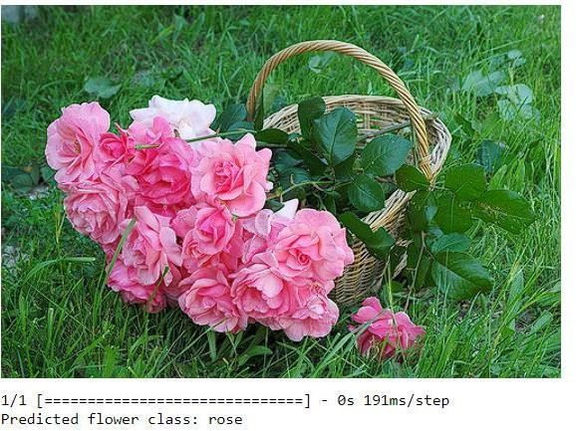

# Write a python program to classify different handwritten character images using the SVM classifier. Source Code:

import numpy as np

import matplotlib.pyplot as plt import ipywidgets as widgets from sklearn import datasets, svm

from sklearn.model_selection import train_test_split from sklearn.preprocessing import StandardScaler from PIL import Image

from IPython.display import display, clear_output import io digits = datasets.load_digits()

X_train, X_test, y_train, y_test = train_test_split(digits.data, digits.target, test_size=0.2, random_state=42) scaler = StandardScaler()

X_train = scaler.fit_transform(X_train) X_test = scaler.transform(X_test) clf = svm.SVC(kernel='linear', probability=True) clf.fit(X_train, y_train) def preprocess_image(img):

img = img.convert('L').resize((8, 8)) img_array = np.array(img) img_array = (img_array / 255.0) * 16 img_array = 16 - img_array

img_array = img_array.flatten().reshape(1, -1) img_array = scaler.transform(img_array) return img_array def predict_character(img):

img_array = preprocess_image(img) prediction = clf.predict(img_array) return prediction[0] def on_upload_change(change):

uploaded_file = change['new'] if uploaded_file:

img = Image.open(io.BytesIO(uploaded_file[0]['content'])) clear_output(wait=True) display(img)

predicted_character = predict_character(img) print(f"Predicted character: {predicted_character}")

uploader = widgets.FileUpload(accept='image/*', multiple=False) uploader.observe(on_upload_change, names='value') display(uploader)

# Output:

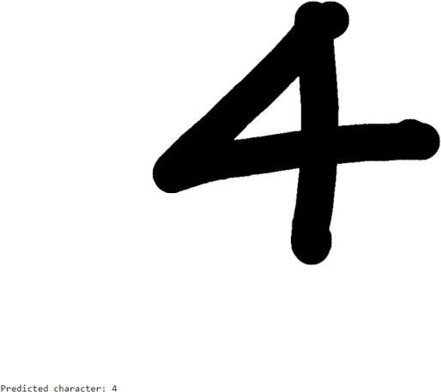

1. **Write a python program to classify different face images using CNN. Source Code:**

import numpy as np

import matplotlib.pyplot as plt import tensorflow as tf from tensorflow.keras import layers, models

from sklearn.model_selection import train_test_split from sklearn.preprocessing import LabelBinarizer from sklearn.metrics import classification_report from sklearn.datasets import fetch_lfw_people

lfw_people = fetch_lfw_people(min_faces_per_person=100, resize=0.4) X = lfw_people.images # Face images (grayscale) y = lfw_people.target # Labels (people)

target_names = lfw_people.target_names # Names of people X = X / 255.0

X = X[..., np.newaxis] label_binarizer = LabelBinarizer() y = label_binarizer.fit_transform(y)

X_train, X_test, y_train, y_test = train_test_split(X, y, test_size=0.2, random_state=42) model = models.Sequential([ layers.Conv2D(32, (3, 3), activation='relu', input_shape=(X_train.shape[1], X_train.shape[2], 1)),

layers.MaxPooling2D((2, 2)),

layers.Conv2D(64, (3, 3), activation='relu'),

layers.MaxPooling2D((2, 2)),

layers.Conv2D(128, (3, 3), activation='relu'),

layers.MaxPooling2D((2, 2)), layers.Flatten(),

layers.Dense(128, activation='relu'), layers.Dense(len(target_names), activation='softmax')

])

model.compile(optimizer='adam', loss='categorical_crossentropy', metrics=['accuracy'])

history = model.fit(X_train, y_train, epochs=10, batch_size=32, validation_split=0.2) test_loss, test_accuracy = model.evaluate(X_test, y_test)

print(f"Test accuracy: {test_accuracy:.2f}") y_pred = model.predict(X_test) y_pred_classes = np.argmax(y_pred, axis=1) y_true_classes = np.argmax(y_test, axis=1)

print(classification_report(y_true_classes, y_pred_classes, target_names=target_names)) plt.figure(figsize=(12, 4)) plt.subplot(1, 2, 1)

plt.plot(history.history['accuracy'], label='Train Accuracy') plt.plot(history.history['val_accuracy'], label='Validation Accuracy') plt.title('Model Accuracy') plt.xlabel('Epoch') plt.ylabel('Accuracy') plt.legend(loc='upper left') plt.subplot(1, 2, 2)

plt.plot(history.history['loss'], label='Train Loss') plt.plot(history.history['val_loss'], label='Validation Loss') plt.title('Model Loss')

plt.xlabel('Epoch') plt.ylabel('Loss') plt.legend(loc='upper left') plt.show() n_samples = 5

plt.figure(figsize=(10, 5)) for i in range(n_samples):

plt.subplot(1, n_samples, i + 1) plt.imshow(X_test[i].reshape(X_test.shape[1], X_test.shape[2]), cmap='gray') plt.title(f"Pred: {target_names[y_pred_classes[i]]}\nTrue: {target_names[y_true_classes[i]]}") plt.axis('off') plt.show()

# Output:

**10. Write a python program to classify breast cancer from histopathological images using VGG-16 and DenseNet- 201 CNN architectures**

# Source Code:

import tensorflow as tf

from tensorflow.keras.applications import VGG16, DenseNet201

from tensorflow.keras.applications.vgg16 import preprocess_input as vgg16_preprocess

from tensorflow.keras.applications.densenet import preprocess_input as densenet_preprocess from tensorflow.keras.preprocessing import image

import numpy as np from PIL import Image import io import ipywidgets as widgets

from IPython.display import display, clear_output

vgg16_model = VGG16(weights='imagenet', include_top=False, input_shape=(224, 224, 3)) densenet_model = DenseNet201(weights='imagenet', include_top=False, input_shape=(224, 224, 3)) def build_custom_model(base_model, num_classes):

model = tf.keras.Sequential([ base_model,

tf.keras.layers.GlobalAveragePooling2D(),

tf.keras.layers.Dense(256, activation='relu'), tf.keras.layers.Dense(num_classes, activation='softmax')

])

model.compile(optimizer='adam', loss='categorical_crossentropy', metrics=['accuracy']) return model num_classes = 2

class_names = ['Benign', 'Malignant']

vgg16_custom_model = build_custom_model(vgg16_model, num_classes) densenet_custom_model = build_custom_model(densenet_model, num_classes) def preprocess_image(img, model_type):

img = img.resize((224, 224)) # Resize image to 224x224 pixels img_array = image.img_to_array(img) # Convert to numpy array img_array = np.expand_dims(img_array, axis=0) # Add batch dimension if model_type == 'vgg16':

img_array = vgg16_preprocess(img_array) elif model_type == 'densenet':

img_array = densenet_preprocess(img_array) return img_array

def predict_vgg16(img):

processed_image = preprocess_image(img, model_type='vgg16') prediction = vgg16_custom_model.predict(processed_image) predicted_class = np.argmax(prediction)

return class_names[predicted_class] def predict_densenet(img):

processed_image = preprocess_image(img, model_type='densenet') prediction = densenet_custom_model.predict(processed_image) predicted_class = np.argmax(prediction)

return class_names[predicted_class] def on_upload_change(change):

uploaded_file = change['new'] if uploaded_file:

img = Image.open(io.BytesIO(uploaded_file[0]['content'])) clear_output(wait=True) display(img)

vgg16_prediction = predict_vgg16(img) densenet_prediction = predict_densenet(img) print(f"VGG-16 Prediction:

{vgg16_prediction}")

print(f"DenseNet-201 Prediction: {densenet_prediction}") uploader = widgets.FileUpload(accept='image/*', multiple=False) uploader.observe(on_upload_change, names='value') display(uploader)

# Output:

